**Ideation Phase**

**Define the Problem Statements**

|  |  |
| --- | --- |
| Date | 25 June 2025 |
| Team ID | LTVIP2025TMID32541 |
| Project Name | Smart Sorting: Transfer Learning for Identifying Rotten Fruits and Vegetables |
| Maximum Marks | 2 Marks |

**Customer Problem Statement Template:**

Users often struggle to visually identify whether fruits or vegetables are still fresh or have begun to rot. This leads to unnecessary waste or potential health risks.

**How might we help users accurately identify fruit and vegetable quality using a simple, AI-powered image-based web tool?**

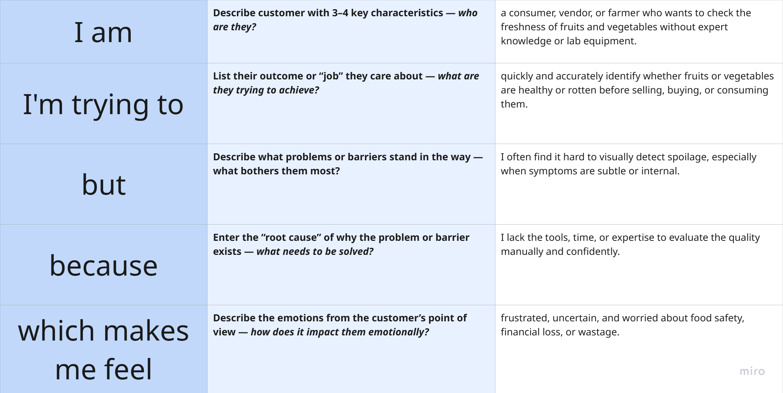

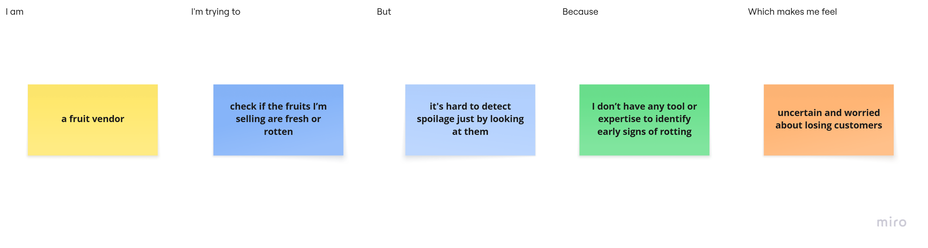

| **Problem Statement (PS)** | **I am** | **I'm trying to** | **But** | **Because** | **Which makes me feel** |
| --- | --- | --- | --- | --- | --- |
| **PS-1** | a fruit vendor who sells produce daily in local markets | ensure I sell only fresh, healthy fruits to customers | it’s hard to detect spoilage just by looking at the fruit | I don’t have tools or knowledge to identify subtle signs of rotting | uncertain, worried about customer satisfaction and loss of sales |
| **PS-2** | a health-conscious consumer who buys fruits and vegetables regularly | make sure the food I eat is safe and fresh | sometimes I can't tell if a fruit is healthy or starting to spoil | outer appearance can be misleading and I lack expert knowledge | frustrated and anxious about food safety and health risks |
| **PS-3** | a supermarket staff responsible for quality checking produce | quickly check if items on shelves are still good | manual inspection takes time and isn’t always accurate | I manage hundreds of items and don’t have time to check each one carefully | overwhelmed and afraid of customer complaints or returns |
| **PS-4** | an online grocery delivery startup founder | ensure only fresh produce is delivered to customers | quality issues are often discovered only after dispatch | no smart system to check images of produce before delivery | concerned about negative reviews and business reputation |